Electric Vehicle Market Performance and Insights
  - Tableau capstone project report
Vishwas Choyal | EN25CS3011066 | Individual project
1 November 2026

1 Introduction

1 1 Project overview
I developed a Tableau dashboard with nine connected visualizations and a three-point story for the supplied market strategy, competitive intelligence and sustainable mobility scenarios. The project turns two EV CSV files into a validated extract, comparable measures and an interactive review workflow.

1 2 Purpose
The report explains the problem-solving approach, data preparation, design choices, testing and results. It follows the supplied final-report outline and accompanies the completed phase templates, portable Tableau workbook and English narrated demonstration.
Dataset measure | Validated value
Raw source records | 300,000 across train and test files
Clean records | 299,999 after removing one exact duplicate
Coverage | 15 vehicle categories, 200 manufacturers, 10 manufacturing countries
Model years | 2018 to 2026
Reported sales sum | 2,323,303,050 units from 296,982 observed rows
Mean observed rating and range | 4.087 out of 5 and 324.5 km

The publisher identifies the source as procedurally generated synthetic data with fictional manufacturer and model names. The dashboard demonstrates an analytical method; its aggregates are not verified real-world market statistics. Model year identifies a vehicle cohort, not a transaction date.

2 Ideation phase

2 1 Problem statement
Emily Johnson needs to compare segment sales, leading manufacturers, customer satisfaction, battery adoption and driving range.
David Chen needs manufacturer rankings and sales shares, battery distribution, manufacturing geography and customer ratings.
Dr Sarah Williams needs battery and range comparisons, manufacturing distribution and satisfaction across vehicle categories.
The shared problem is fragmented comparison. Raw rows contain commercial, technical and customer measures, but users need consistent definitions and linked views to compare them. Each persona is supplied by the project overview; no customer interviews are claimed.

2 2 Empathy map canvas
Canvas area | Emily scenario response
Goal | Prioritize vehicle segments using demand, satisfaction, technology and range.
See and do | Inspect a large CSV, compare categories and investigate selected segments.
Hear and say | Scenario assumption: leadership needs evidence for a portfolio review.
Think and feel | Needs confidence in metric consistency and limitations.
Pains | Missing values, repeated spreadsheet comparisons and ambiguous year meaning.
Gains | One dashboard with defined measures, linked filters and traceable findings.

2 3 Brainstorming
I compared an interactive dashboard, static spreadsheet summaries, a battery report and a classifier. The Tableau dashboard best matches all three scenarios and the nine-visual requirement. A classifier would require a separate predictive objective and holdout evaluation. The chosen solution therefore remains descriptive.
Completed editable canvas responses and the retained linked-template references are included in the ideation and design documents.

3 Requirement analysis

3 1 Customer journey map
Discover: the user opens the dashboard and reads the scope note. Compare: the user inspects category sales and selects a segment. Decide: the user compares the linked manufacturer, battery, geography, range and satisfaction views, then records a qualified finding. Clear selection restores the full dataset.

3 2 Solution requirements
Requirement | Acceptance evidence
Reliable preparation | Both CSVs inventoried, one exact duplicate removed, nulls retained.
Scenario coverage | Nine charts cover sales, manufacturers, technology, geography, range and ratings.
Interactive analysis | Hatchback selection changes linked charts; clearing restores totals.
Traceable delivery | Portable TWBX, report, phase templates, public dashboard and narrated demo.
Usability and reliability | Units and model-year meaning are labelled; aggregate totals reconcile.

3 3 Data flow diagram
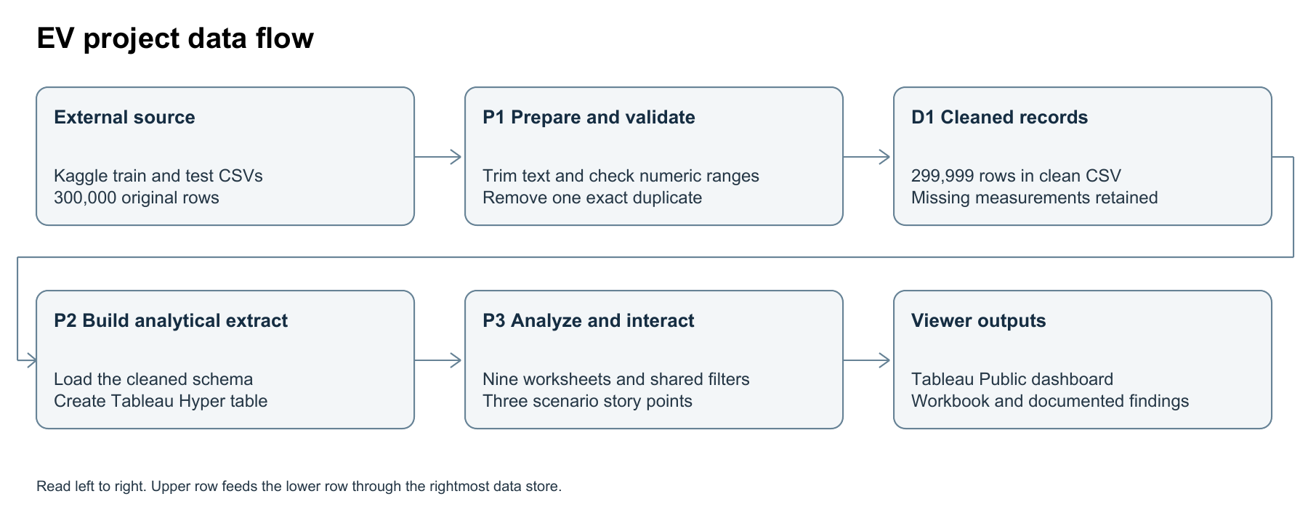

3 4 Technology stack
Python and pandas prepare and reconcile the CSV data. Tableau Hyper API builds the extract. Tableau Public 2026.3 authors the worksheets, dashboard and story. GitHub distributes project files, and Google Drive hosts the demonstration. Snowflake is outside the implemented Tableau track.

4 Project design

4 1 Problem solution fit
The solution supports repeatable comparisons for strategy directors, BI managers and mobility researchers. A shared extract reduces inconsistent aggregation, while category selection connects the questions across views. The main constraints are missing measurements, source sampling and synthetic data. The dashboard improves analytical access without establishing real-market validity.

4 2 Proposed solution
The 1600 by 1200 dashboard uses a three-by-three arrangement. Sales use sums, customer ratings and technical characteristics use unweighted means of observed records, and manufacturer shares use a fixed overall sales denominator. A three-point story introduces Emily through category sales, David through manufacturers and Sarah through battery cycle life.

4 3 Solution architecture
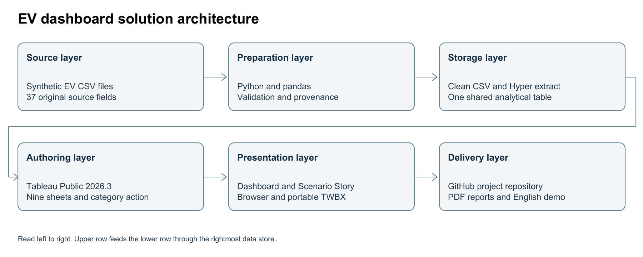
All nine worksheets share one analytical table. The category-selection action targets the linked charts. Top-ten manufacturer membership is fixed globally, so filtering compares category results for those same manufacturers. Sales Share remains a contribution to the complete dataset total rather than a share within the selected category.
Calculation | Definition
Record Count | 1 per retained record
Reported sales | SUM(annual_sales_units), ignoring nulls
Sales Share | SUM(annual_sales_units) / MIN({FIXED : SUM(annual_sales_units)})
Average rating or range | AVG of available source-record values

5 Project planning and scheduling

5 1 Project planning
This individual project was organized into acquisition, preparation, visual development, dashboard interaction, testing, documentation and demonstration. The phase plan uses relative story-point estimates rather than an asserted historical team velocity. The Tableau development and data checks preceded documentation and publication.
Stage | Produced evidence
Acquire and prepare | Raw source files, repeatable preparation script and data-quality summary.
Build and validate | Nine worksheets, dashboard, story and native portable workbook.
Explain and deliver | Completed phase documents, this report and English narrated screen recording.
Review | Repository and public links are supplied for the SkillWallet review workflow.

6 Functional and performance testing

6 1 Performance testing
Check | Observed result
Source inventory | 200,000 train rows plus 100,000 test rows; 37 source fields.
Exact deduplication | One identical row removed; retained count 299,999.
Null audit | 3,017 missing sales, 5,908 missing ratings and 5,814 missing cycle-life values remain unknown.
Range checks | No invalid selected values found for sales, rating, range, capacity or price.
Aggregate reconciliation | Tableau sales total reconciled to Python: 2,323,303,050.
Filter behavior | Hatchback selection updated linked views; clearing restored full data.
Selected segment | Hatchback showed 231,033,059 sales units and 25,713 records.
Portability and publication | TWBX reopened natively; dashboard and story published successfully.

These checks validate function and aggregate consistency. No controlled dashboard-latency benchmark or concurrent-user load test was performed. Hyper preparation runtime is not presented as a dashboard response-time measurement.

7 Results

7 1 Output screenshots
The complete dashboard connects all nine comparisons. Selecting a category updates the linked charts. The next pages map each view to a supplied scenario and explain the result. Screenshots are native Tableau renders.
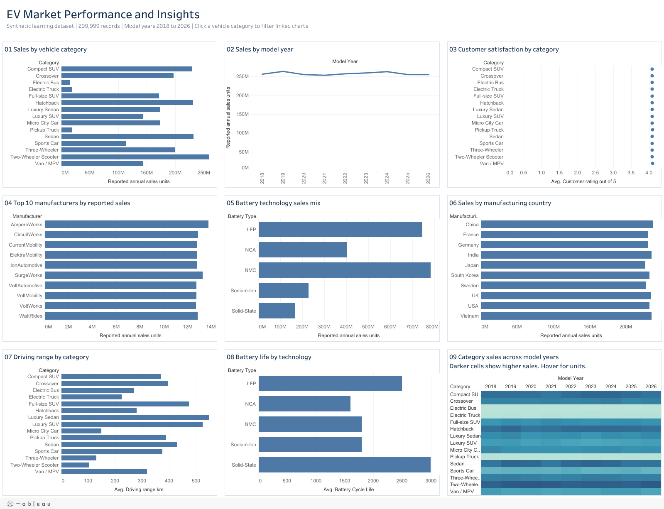
The synthetic-data label, record count and model-year scope remain visible in the dashboard title. The first chart drives category filtering; hovering over a mark supplies additional measures.

7 Results continued

View 1 Which vehicle categories contribute most reported sales
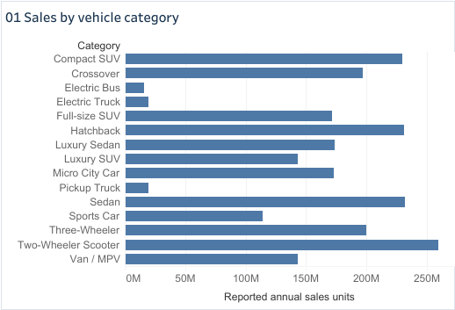
Scenario focus: Emily. Two-Wheeler Scooter contributes the largest reported category sales, 259,647,705 units (11.2% of dataset sales).

View 2 How do reported sales differ across model-year cohorts
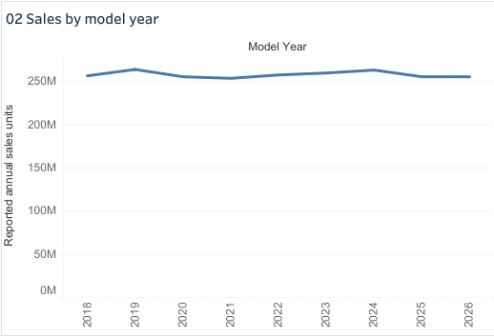
Scenario focus: Emily. Model-year cohorts span 2018 to 2026. Differences between cohorts are not evidence of transaction-year market growth.

7 Results continued

View 3 How do average customer ratings differ across vehicle categories
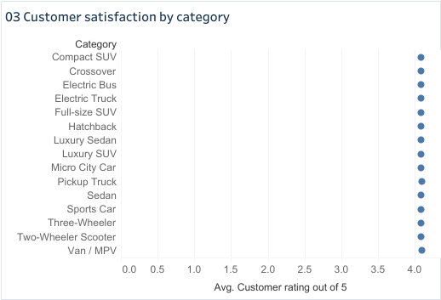
Scenario focus: Emily and Sarah. Pickup Truck has the highest mean category rating, 4.09 out of five, among records with observed ratings.

View 4 Which ten manufacturers lead reported sales and what shares do they contribute
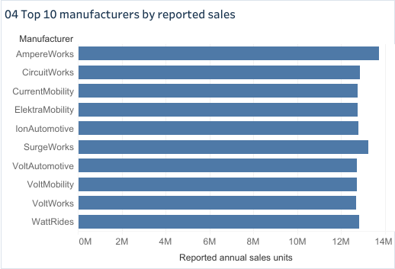
Scenario focus: David. AmpereWorks leads reported manufacturer sales with 13,736,241 units (0.59% of dataset sales). Names are fictional.

7 Results continued

View 5 Which battery technologies account for the most reported sales
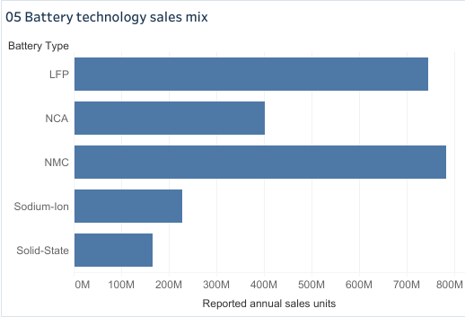
Scenario focus: Emily and David. NMC leads battery-technology sales with 33.7% of reported dataset sales.

View 6 Which manufacturing countries are associated with the most reported sales
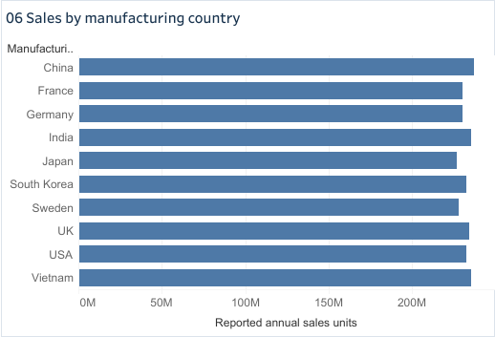
Scenario focus: David and Sarah. China leads sales associated with manufacturing country at 237,384,272 units. This measures neither factory output nor destination sales.

7 Results continued

View 7 How does average driving range differ across vehicle categories
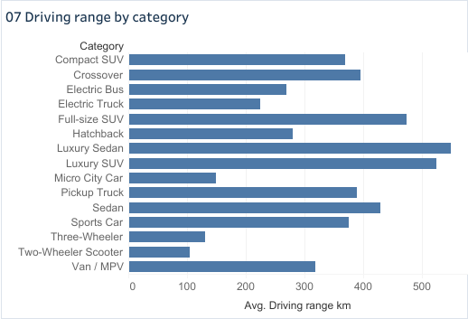
Scenario focus: Emily and Sarah. Luxury Sedan has the highest mean category range, 550.2 km. Different vehicle use cases limit direct comparisons.

View 8 How do battery technologies compare in average cycle life and driving range
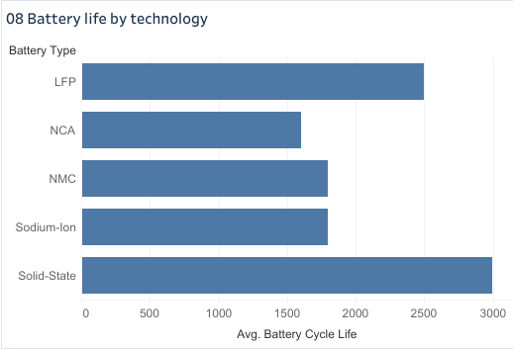
Scenario focus: Sarah. Average battery cycle life varies by chemistry. Compare cycle life in the bars and inspect average range and capacity in tooltips. These are synthetic technology characteristics.

7 Results continued

View 9 How does the category sales mix differ across model-year cohorts
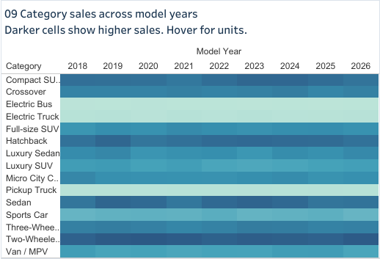
Scenario focus: Emily and David. The category-by-model-year heatmap highlights large sales cells and supports cohort composition comparisons. Missing sales remain unknown.

8 Advantages and disadvantages
The dashboard gives all three personas one shared set of measures. Linked selection reduces repeated manual comparison, the extract supports portable review, and the phase documents make the preparation and interpretation reproducible. Tooltips add context without crowding every chart.
The source is synthetic, missing measurements affect observation counts, and record-level means are not customer-weighted averages. Manufacturing country is not the sales destination. The fixed manufacturer denominator and fixed top-ten membership require clear explanation. Model-year cohorts cannot establish real annual growth.

9 Conclusion
The implemented dashboard answers the supplied descriptive questions through nine visualizations and a scenario story. Two-wheeler scooters lead category sales in the sample, AmpereWorks leads manufacturer sales, NMC leads battery sales, and solid-state records have the highest average battery cycle life. These findings illustrate the workflow and remain bounded by the synthetic source.

10 Future scope
A future version should use measured market data with transaction dates, documented sampling and refresh ownership. It could add sales destination, customer counts for weighted satisfaction, and measured battery tests. Controlled response-time and load tests would support deployment decisions. Environmental conclusions would require lifecycle or emissions evidence rather than range alone.

11 Appendix

Source code and reproducibility
The repository includes the preparation and extract scripts, aggregate summaries and data-quality results. To reproduce, download the two original CSV files, run preparation with pandas, create the Hyper extract, open the workbook and republish the refreshed result. Use the TWBX for portable review because it embeds the extract.

Dataset and interpretation
Kaggle source https://www.kaggle.com/datasets/tharishreddy22/electric-vehicle-market-classification-dataset
Source author: tharishreddy22. Dataset license: MIT, according to publisher metadata. The source files are combined for descriptive analysis; no predictive generalization or test-set accuracy is claimed. Original phase-template and linked-canvas attribution is retained in the supplied documents.

Project links
Tableau dashboard https://public.tableau.com/views/EVMarketInsights_17934697727980/EVMarketInsights
Scenario Story https://public.tableau.com/views/EVMarketInsights_17934697727980/ScenarioStory
GitHub repository https://github.com/VishwasChoyal0/ev-market-insights-tableau
English demo on Google Drive https://drive.google.com/file/d/1XmrLik-fGaaCRTDb6RiIGywPqFDB0BBD/view?usp=sharing

Deliverable guide
EV Market Insights.twbx is the portable dashboard and story. EV Market Insights.twb is the editable workbook definition. Project Demo.mp4 contains the English walkthrough, recorded worksheet views and dashboard interaction. Completed Templates contains the phase Word files and PDFs. This report consolidates the project explanation and review links.
The demonstration uses English synthesized narration. Supplied personas and scenario-derived empathy assumptions are identified as such; no interview, meeting, field test or real-world market outcome is invented.

